Unified Kill chain:
Introductions:
Understanding the behavior, objectives and methodologies for the cyber threat is vital part of cyber defence and also know as cybersecurity posture.

What is kill chain:
The kill chain is derived from a military term and is used to identify stages of attack.
In cybersecurity it is used to describes the methodologies of the attacker and APT group
So we can encounter by identify at which stage or phase of attack they are for example

Threat Modelling:
This technique is used to identify the risk and mitigate them in order to improve the security of the systems.
- In this we identify the vulnerabilities and weakness in the system and how to mitigate them
- Identified the system and applications that need to be secured.
- Creating a plan of actions to secure these systems.
- Putting in policies to prevent these vulnerabilities from occurring again where possible ( for example implementing a software development life cycle (SDLC) for an applications or training employees on phishing awareness).

Threat modelling is an important procedure in reducing the risk within a system or application, as it creates a high-level overview of an organisation's IT assets (an asset in IT is a piece of software or hardware) and the procedures to resolve vulnerabilities.
The UKC can encourage threat modelling as the UKC framework helps identify potential attack surfaces and how these systems may be exploited.

STRIDE, DREAD and CVSS are all the frameworks specifically used in threat modelling.
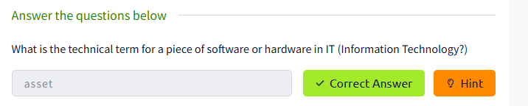

Introduction to unified kill chain (UKC):
The UKC released in a 2017 and updated in 2022 it has details 18 stages and almost cover all the steps that an adversaries used in their attack.
From Reconnaissance to objectives.

Reconnaissance:
The attacker gathers initial data about the target.
Weaponization:
Craft the payload according to the environment.
Delivery:
Deliver the crafted payload to the target machine.
Social Engineering:
In this technique manipulate the people to perform harmful actions.
Exploitations:
Exploit the vulnerabilities in the system.
Persistance:
After exploitation attacker make sure to gain the persistence.
Defence Evasion:
In this technique the hacker bypass the security tools of the system.
Command & Control:
The attacker takes the command of the system
Pivoting:
Tunnelling traffic through a controlled system to other system that are not directly accessible from the system.
Discovery:
Technique to gain knowledge about the network and system with in the organizations.
Privilege Escalations:
Takes the higher level control then user like administrator control.
Credential Access:
Gain the access of the credentials
Lateral Movements:
Techniques to access the all system including the remote system.
Collections:
Gathering of the data and other information’s.
Exfiltrations:
Techniques that result or aid in an attacker removing data from target network.
Impact:
Technique aimed at manipulating, interrupting or destroying the target system or data.
Objectives:
To perfrom it’s objective on the compromised system.

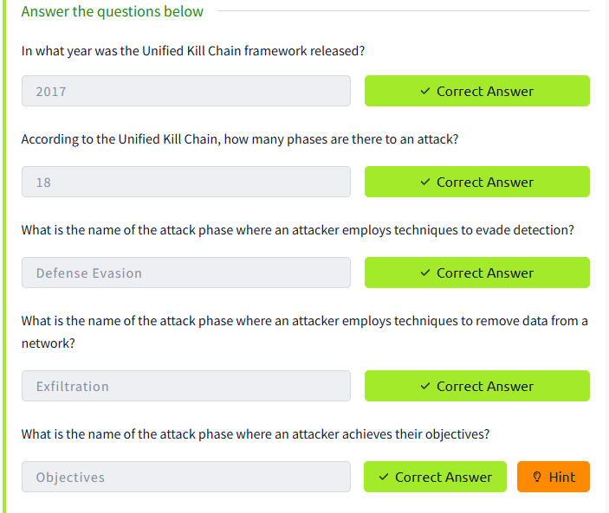

Phase: In (Initial Foothold):
In the initial foothold the main purpose of the attacker is used to discover and find potential vulnerabilities to gain access to the system.

It follows these techniques like.
Reconnaissance, weaponization, delivery, social engineering , exploitation , Persistence, Defense evasion, command and control and Pivoting.
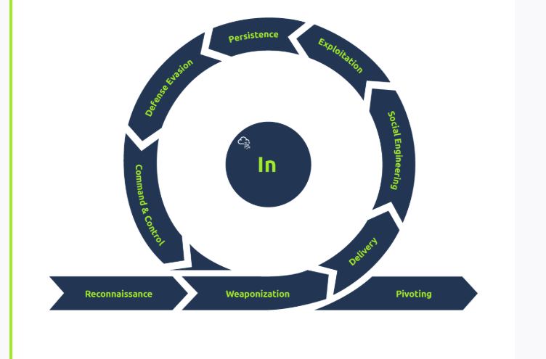

- Discovering what systems and services are running on the target, this is beneficial information in the weaponisation and exploitation phases of this section.
- Finding contact lists or lists of employees that can be impersonated or used in either a social engineering or phishing attack.
- Looking for potential credentials that may be of use in later stages, such as pivoting or initial access.
- Understanding the network topology and other networked systems can be used to pivot too.

- Social Engineering:
Getting a user to open a malicious attachment.
- Impersonating a web page and having the user enter their credentials.
- Calling or visiting the target and impersonating a user (for example, requesting a password reset) or being able to gain access to areas of a site that the attacker would not previously be capable of (for example, impersonating a utility engineer).

Exploitation (MITRE Tactic TA0002)

This phase of the UKC describes how an attacker takes advantage of weaknesses or vulnerabilities present in a system. The UKC defines "Exploitation" as abuse of vulnerabilities to perform code execution. For example:
- Uploading and executing a reverse shell to a web application.
- Interfering with an automated script on the system to execute code.
- Abusing a web application vulnerability to execute code on the system it is running on.
Persistence (MITRE Tactic TA0003)

This phase of the UKC is rather short and simple. Specifically, this phase of the UKC describes the techniques an adversary uses to maintain access to a system they have gained an initial foothold on. For example:
- Creating a service on the target system that will allow the attacker to regain access.
- Adding the target system to a Command & Control server where commands can be executed remotely at any time.
- Leaving other forms of backdoors that execute when a certain action occurs on the system (i.e. a reverse shell will execute when a system administrator logs in).

Defence Evasion (MITRE Tactic TA0005)
ence Evasion" section of the UKC is one of the more valuable phases of the UKC. This phase specifically is used to understand the techniques an adversary uses to evade defensive measures put in place in the system or network. For example, this could be:
- Web application firewalls.
- Network firewalls.
- Anti-virus systems on the target machine.
- Intrusion detection systems.
This phase is valuable when analysing an attack as it helps form a response and better yet - gives the defensive team information on how they can improve their defence systems in the future.
Command & Control (MITRE Tactic TA0011)
The "Command & Control" phase of the UKC combines the efforts an adversary made during the "Weaponization" stage of the UKC to establish communications between the adversary and target system.
An adversary can establish command and control of a target system to achieve its action on objectives. For example, the adversary can:
- Execute commands.
- Steal data, credentials and other information.
- Use the controlled server to pivot to other systems on the network.

Pivoting (MITRE Tactic TA0008)
"Pivoting" is the technique an adversary uses to reach other systems within a network that are not otherwise accessible (for example, they are not exposed to the internet). There are often many systems in a network that are not directly reachable and often contain valuable data or have weaker security.
For example, an adversary can gain access to a web server that is publically accessible to attack other systems that are within the same network (but are not accessible via the internet).

Phase: Through (Network Propagation):

It follows by the initial foot hold. In this the attacker want to deep dive to gain more access to achieve its goals. Here comes the pivoting in which the 1 compromised system gives access to the other system that are not accessible from the outside.
Pivoting (MITRE Tactic TA0008)
Once the attacker has access to the system, they would use it as their staging site and a tunnel between their command operations and the victim’s network. The system would also be used as the distribution point for all malware and backdoors at later stages.
Discovery (MITRE Tactic TA0007)
The adversary would uncover information about the system and the network it is connected to. Within this stage, the knowledge base would be built from the active user accounts, the permissions granted, applications and software in use, web browser activity, files, directories and network shares, and system configurations.
Privilege Escalation (MITRE Tactic TA0004)
Following their knowledge-gathering, the adversary would try to gain more prominent permissions within the pivot system. They would leverage the information on the accounts present with vulnerabilities and misconfigurations found to elevate their access to one of the following superior levels:
- SYSTEM/ ROOT.
- Local Administrator.
- A user account with Admin-like access.
- A user account with specific access or functions.
Execution (MITRE Tactic TA0002)
This is where they deploy their malicious code using the pivot system as their host. Remote trojans, C2 scripts, malicious links and scheduled tasks are deployed and created to facilitate a recurring presence on the system and uphold their persistence.
Credential Access (MITRE Tactic TA0006)
Working hand in hand with the Privilege Escalation stage, the adversary would attempt to steal account names and passwords through various methods, including keylogging and credential dumping. This makes them harder to detect during their attack as they would be using legitimate credentials.
Lateral Movement (MITRE Tactic TA0008)
With the credentials and elevated privileges, the adversary would seek to move through the network and jump onto other targeted systems to achieve their primary objective. The stealthier the technique used, the better.
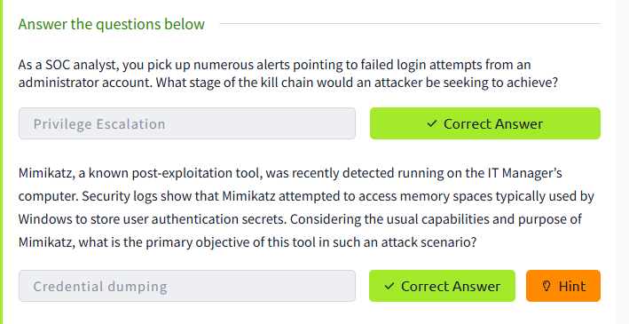

Phase: Out (Action on Objectives):
This is the final stage of the attack in this stage the adversaries perform it’s task according to it’s goals. At this stage the compromised the CIA traid like: Confidentially , integrity and availability i.e (CIA) traid
o elevate their compromise, the adversary would seek to steal data, which would be packaged using encryption measures and compression to avoid any detection. The C2 channel and tunnel deployed in the earlier phases will come in handy during this process.
Impact (MITRE Tactic TA0040)
If the adversary seeks to compromise the integrity and availability of the data assets, they would manipulate, interrupt or destroy these assets. The goal would be to disrupt business and operational processes and may involve removing account access, disk wipes, and data encryption such as ransomware, defacement and denial of service (DoS) attacks.
Objectives
With all the power and access to the systems and network, the adversary would seek to achieve their strategic goal for the attack.
For example, if the attack was financially motivated, they may seek to encrypt files and systems with ransomware and ask for payment to release the data. In other instances, the attacker may seek to damage the reputation of the business, and they would release private and confidential information to the public.

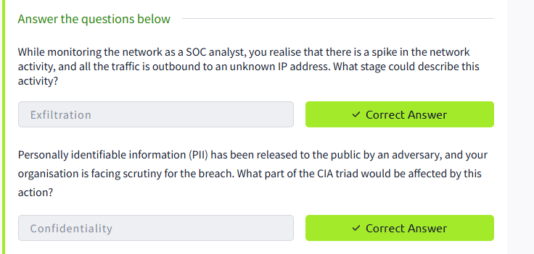

Practical:

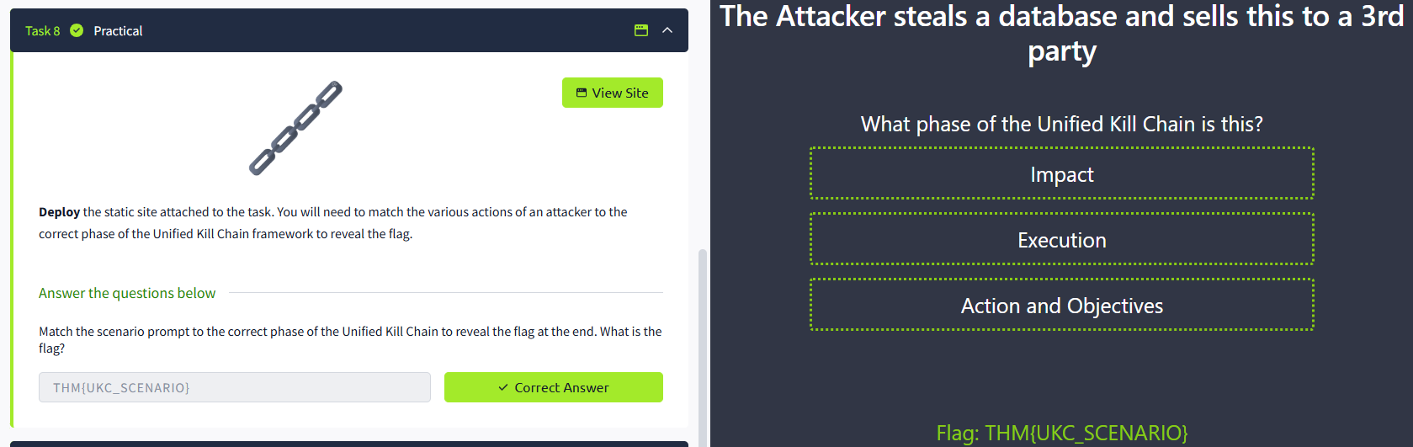

Conclusions:
